# **Identifying Plant Diseases Using Distributed Deep Learning**

Team 14

Riya Mate :002818432

Bharath Bhaskar :002849480

### **Introduction**

#### **Background**

Plant diseases have been a significant challenge throughout human history, with records of their impact spanning thousands of years. As agriculture advanced and societies grew increasingly dependent on crops for sustenance and trade, the effects of plant diseases became more profound. Today, with a rapidly expanding global population and rising environmental concerns, addressing plant diseases is more critical than ever. These diseases not only undermine food security by reducing crop yields and quality but also disrupt ecosystems, threaten biodiversity, and create ecological imbalances. Moreover, conventional methods of controlling plant diseases, such as the use of chemical pesticides, often harm the environment, underscoring the need for sustainable solutions. Consequently, understanding, preventing, and managing plant diseases are essential steps to ensure agricultural productivity and environmental stability in the face of these challenges.

#### **Motivation**

According to the Food and Agriculture Organization (FAO), plant diseases cause an annual reduction of 20-40% in global crop yields, resulting in billions of dollars in economic losses for farmers. These diseases also contribute to food shortages and price fluctuations, disproportionately affecting vulnerable populations in developing nations. Their environmental impact is equally concerning, as they disrupt essential ecosystem services, degrade soil quality, and threaten biodiversity. This project aims to develop an advanced system for the accurate identification and monitoring of diseased plants, addressing these challenges by equipping farmers and researchers with timely information for targeted interventions. By leveraging advancements in artificial intelligence (AI) and image processing, the project seeks to improve disease surveillance while reducing reliance on chemical inputs, contributing to sustainable agricultural practices, environmental conservation, and enhanced global food security.

#### **Goal**

The primary objective of this project is to develop an innovative plant disease detection system utilizing PyTorch and multiprocessing techniques. This system is designed to accurately identify and classify plant diseases from images by leveraging advanced deep learning models and parallel processing to achieve high-performance detection. By using PyTorch for model training and development, combined with multiprocessing for efficient data handling, the aim is to create a robust and scalable solution capable of detecting a wide array of plant diseases. The ultimate goal is to replace subjective, time-consuming manual inspections with a proactive, automated approach to disease management, thereby minimizing the environmental impact of traditional disease control methods.

### **Methodology**

This project, titled *"Classification of Botanical Infections Using Distributed Deep Learning,"* leverages PyTorch's Distributed Data Parallel (DDP) framework to classify plant diseases efficiently from a large dataset. The methodology focuses on multiple stages to ensure accuracy and scalability in disease classification.

#### **Steps:**

1. **Data Collection and Preparation:** Gathering, cleaning, and preparing high-quality image data for processing.
2. **Exploratory Data Analysis (EDA):** Deriving insights from the dataset to identify patterns and inform feature engineering.
3. **Feature Engineering:** Using multiprocessing techniques to optimize data for deep learning models.
4. **Model Development and Evaluation:**
   * **Single GPU Implementation:** Baseline model training on a single GPU.
   * **Distributed Data Parallelism (DDP):** Scaling model training across multiple GPUs for improved efficiency and performance.
5. **Conclusion:** Synthesizing results and evaluating the effectiveness of the methodology.

#### **Data Collection and Preparation**

The foundation of this project lies in the use of essential libraries tailored for deep learning tasks. PyTorch is the core framework, providing a flexible and dynamic platform for model development. Complementary libraries such as NumPy and Pandas enable efficient manipulation and analysis of large datasets. For visualization, Matplotlib is employed to create intuitive plots and charts, offering deeper insights into the dataset's structure and variability.

In the realm of image processing, libraries like PIL and torchvision.transforms are used for preprocessing and augmenting image data, ensuring that the training data reflects real-world conditions. The torchvision.datasets module organizes image data into formats suitable for deep learning models. Additionally, Albumentations is integrated to perform advanced augmentation techniques, enhancing dataset diversity and robustness.

The torchsummary library is also utilized to analyze and fine-tune the model architecture, allowing for optimization of neural network parameters and layers. This comprehensive toolkit enables precise analysis and the construction of high-performing models, effectively addressing the challenges of classifying botanical infections.

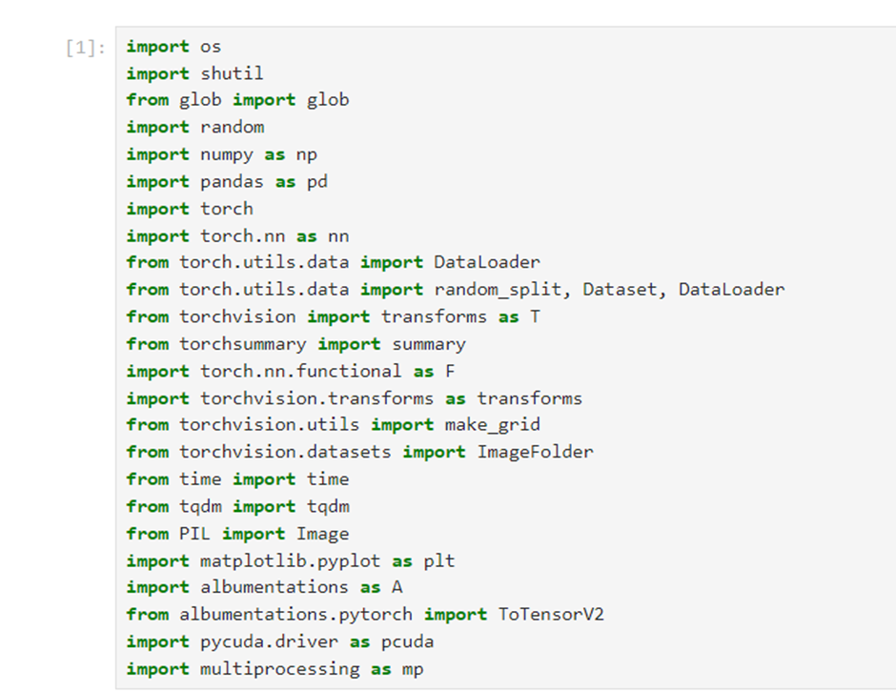

The Plant Diseases Training Dataset is an extensive collection of images featuring various plant species affected by a wide range of diseases with varying levels of severity. The dataset, approximately 5.91 GB (around 6 GB) in size, comprises 95,900 images in .jpg format. It is specifically curated to facilitate research and development in plant disease detection and classification using machine learning techniques.

#### **Dataset Contents:**

* **Plant Species:** The dataset includes images of numerous plant species commonly impacted by diseases, such as tomatoes, potatoes, cherries, grapes, and apples.
* **Disease Types:** The dataset features plants showing symptoms of diverse disease categories, including:
  + **Fungal infections:** Powdery mildew, rust.
  + **Bacterial infections:** Blight, leaf spot.
  + **Viral diseases:** Mosaic virus, yellowing.
  + **Other conditions:** Root rot, nematode infestation.

#### **Dataset Statistics:**

This dataset has been created by integrating multiple datasets into a single, unified collection to provide comprehensive coverage for machine learning applications.

**Statistics:**

The dataset is built by merging multiple datasets into one.

| **Dataset** | **No. of Samples** | **No. of Classes** |
| --- | --- | --- |
| **Cassava Leaf Disease Dataset**    **Rice Leaf Disease Images**    **Plant Village**    **Potato Leaf Disease**    **Plant Pathology**    **ESCA-dataset**    **Sugarcane Leaf Image Dataset**    **Potato Leaf Disease** | **21400**    **5932**    **54303**    **4072**    **2700**    **1768**    **2569**    **1500** | **5**    **4**    **38**    **3**    **3**    **2**    **5**    **3** |

# **Dataset Source:**

[**https://www.kaggle.com/datasets/nirmalsankalana/plant-diseases-training-dataset**](https://www.kaggle.com/datasets/nirmalsankalana/plant-diseases-training-dataset)

# **Data Preparation:**

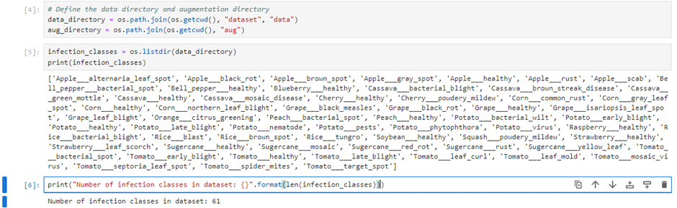

During the preparatory phase of our project, we established a robust data infrastructure essential for the classification task. Upon accessing and organizing the dataset, we identified a diverse and comprehensive range of infection classes. These classes span various states of plant health and disease, from "Apple___Apple_scab" to "Tomato___Tomato_Yellow_Leaf_Curl_Virus," totaling 61 distinct categories. This breadth reflects the complexity and real-world variability of plant diseases, emphasizing the challenging nature of the classification problem.

By systematically navigating through the dataset, we cataloged the directories for each infection class, providing a clear and organized taxonomy. This process not only verified the successful integration of the dataset into our workflow but also ensured that all categories were well-represented. The extensive coverage of infection classes within the dataset forms a solid foundation for model training, encompassing a wide variety of plant species and disease types.

The inclusion of 61 unique infection classes underscores the dataset's richness and diversity, which is critical for training a distributed deep learning model. This diversity ensures that the model is capable of delivering accurate and versatile diagnoses across a broad spectrum of plant species and disease manifestations, making it a valuable tool for agricultural applications.

# **RESULTS AND ANALYSIS**

To gain insights into our dataset's diverse composition, we have employed custom functions that reveal its multifaceted nature. Among these, the get_unique_info() function plays a pivotal role. When invoked with the 'plants' argument, it extracts a comprehensive list of unique plant species present in the dataset. This analysis highlights a total of 18 distinct species, including varieties such as 'Apple,' 'Blueberry,' 'Cherry,' and more.

The function's utility extends beyond plant identification. When supplied with the 'infection_classes' argument, it quantifies the unique infection states within the dataset. This count underscores the dataset's inherent complexity, reflecting the depth of insights our distributed deep learning model aims to uncover in plant pathology.

These findings go beyond mere statistics; they exemplify the intricate challenges of our task. The diversity of 18 plant species illustrates the breadth of our agricultural scope, while the 61 unique infection classes underscore the depth of our analytical and predictive efforts. Together, they represent a dataset rich in complexity and potential, setting the stage for developing a robust deep learning solution poised to advance plant health management and disease prevention.

# **Exploratory Data Analysis (EDA):**

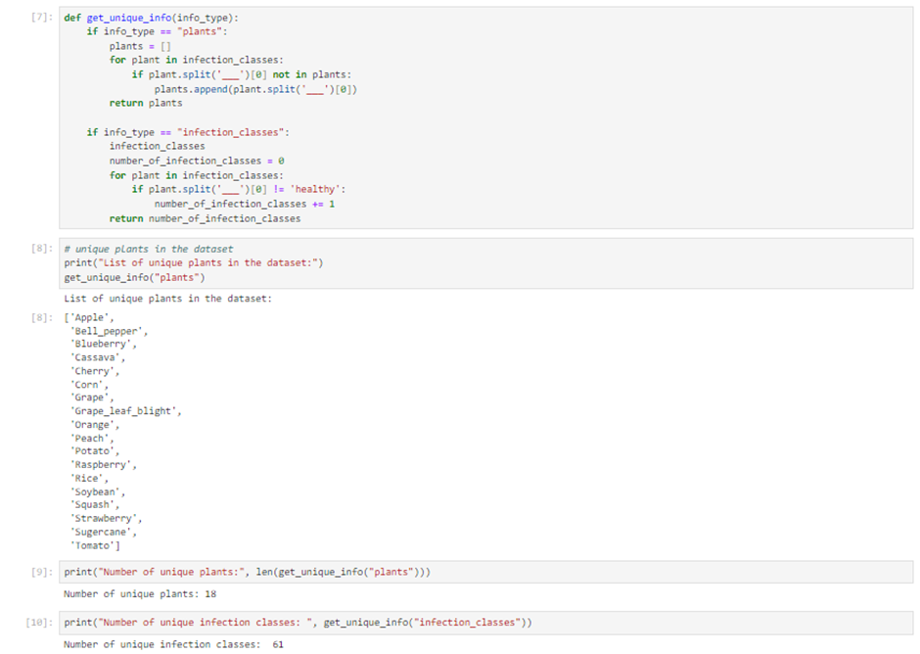

The customized BotanyDataset class, built as an extension of PyTorch's foundational Dataset class, provides an efficient solution for managing and interfacing with botanical data. This class is designed to address challenges such as class imbalance by incorporating logic to handle optional augmented data directories. It dynamically tracks image paths and class counts, ensuring a well-organized and accessible data structure for seamless model ingestion.

The class also introduces utility functions like get_classname, which efficiently retrieves the label for a given image. Additionally, it overrides essential methods such as __len__ and __getitem__, with the latter retrieving an image and its corresponding label while seamlessly applying any specified transformations.

By combining systematic data curation with enhanced accessibility, the BotanyDataset class exemplifies a strategic approach to data management. It lays a strong foundation for subsequent phases of deep learning model training, ensuring both efficiency and adaptability.

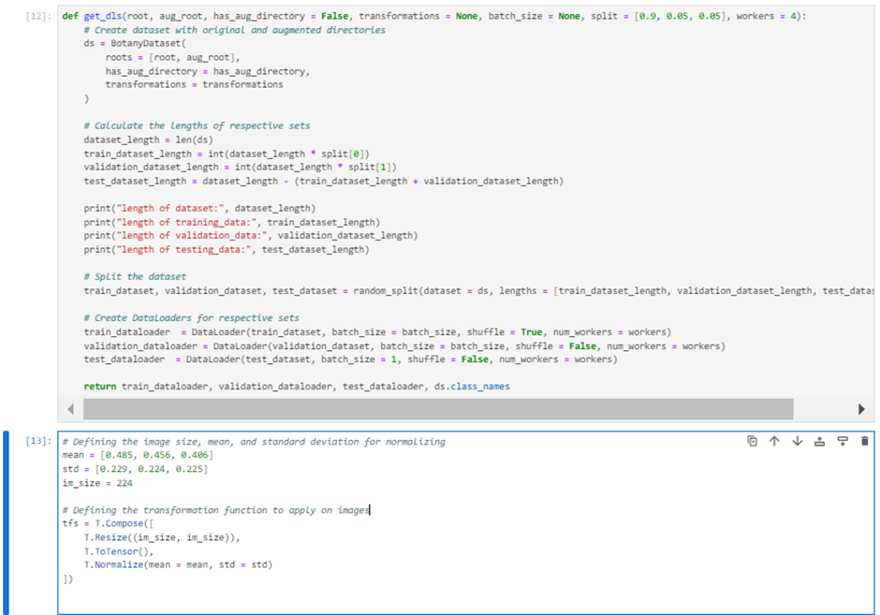

In our methodological framework, we present a robust dataset handling mechanism through the get_dls function. This function is responsible for creating the BotanyDataset object with the appropriate parameters and partitioning the dataset into training, validation, and testing subsets. Designed to support data augmentation strategies, it enhances the dataset's resilience to overfitting and improves the model's generalization capabilities. By calculating subset sizes based on predefined split ratios and partitioning the data accordingly, we ensure balanced representation across all phases of model training and evaluation. This stratified approach is vital for accurately assessing the model’s performance and its ability to generalize to unseen data.

To further optimize the model’s learning from this structured dataset, we implement a series of transformations. These include resizing images to standardized dimensions, converting them into tensors, and normalizing pixel values based on predefined means and standard deviations. Such preprocessing steps are essential for preparing the images for efficient neural network processing, enabling the model to extract invariant features irrespective of variations in scale or color distribution.

Normalization is more than a standard step; it plays a pivotal role in facilitating effective model convergence and enhancing performance. By streamlining this preprocessing pipeline, we create a reproducible and efficient workflow that seamlessly integrates data into our distributed deep learning system. This marks a critical milestone in achieving accurate classification of botanical infections.

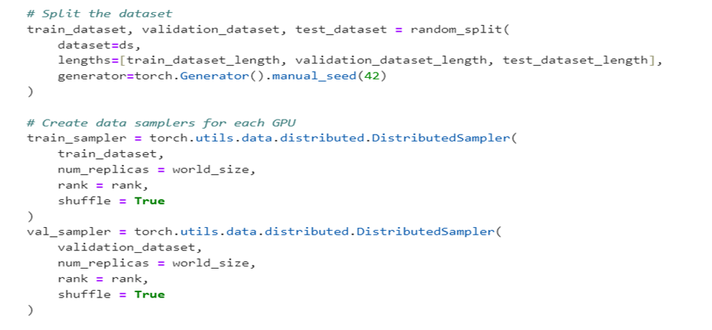

The DistributedSampler from PyTorch's torch.utils.data module plays a vital role in efficient data handling for distributed training. It divides the dataset among multiple processes, often running on two or more GPUs, ensuring that each process processes a unique subset of the data. This partitioning is essential for balancing the workload, maximizing parallelism, and effectively utilizing large-scale computing resources.

In the get_dls function, the DistributedSampler is instantiated for both the training and validation datasets. Key parameters include the dataset, the total number of processes (world_size), the rank of each process, and whether the data should be shuffled. Shuffling introduces randomness into the data order, enhancing the model’s ability to generalize and reducing the risk of overfitting.

The DistributedSampler operates by evenly dividing the dataset among processes based on their rank and the total number of processes. This ensures that each process handles a distinct subset, avoiding overlap and minimizing inefficiencies or training inconsistencies. When shuffling is enabled, the sampler rearranges the data at the start of each epoch, ensuring that every process encounters the dataset in a different order, contributing to more robust learning. During training, each process uses indices from the sampler to load data from its allocated subset, ensuring consistency and fairness across the distributed training regimen.

Using the DistributedSampler offers numerous advantages in distributed training setups. It ensures scalability, efficient utilization of GPUs or worker nodes, and consistent training conditions. By facilitating effective data parallelism, it optimizes training time while maintaining quality and efficiency. This approach is particularly well-suited for handling large datasets and complex model architectures in multi-GPU environments, making it a cornerstone of high-performance distributed deep learning workflows.

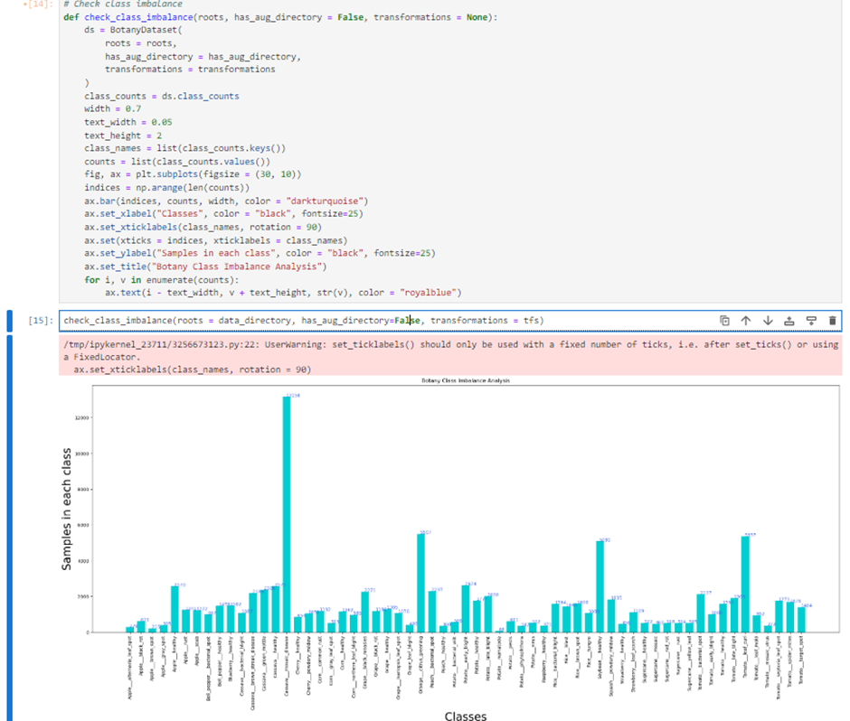

The graphical visualization presented highlights a critical analysis conducted to detect class imbalance within our dataset. Represented through a bar chart, the visualization quantifies the number of samples available for each infection class. This evaluation is vital in machine learning, as imbalanced class distributions can significantly affect model performance, often causing the model to overfit the majority class while underperforming on minority classes.

The check_class_imbalance() function facilitates this analysis by creating a BotanyDataset object to access class count data and leveraging Matplotlib to generate the visualization. The resulting bar chart provides a clear depiction of the sample distribution across classes, revealing notable under-representation in certain classes.

Such insights are crucial for informing subsequent strategies to address the imbalance, such as augmenting data for under-represented classes, employing re-sampling techniques, or applying specialized loss functions during neural network training. These steps are essential for ensuring that the model learns effectively across all classes, thereby improving its generalizability and predictive accuracy.

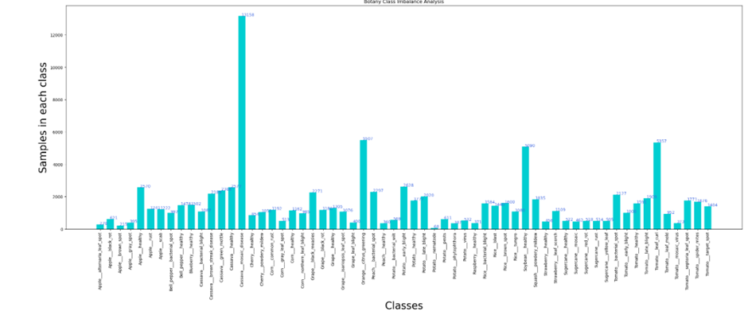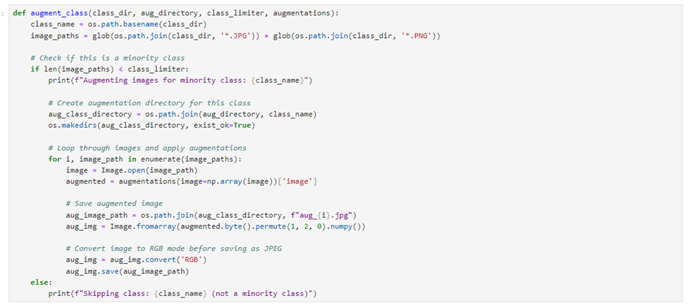

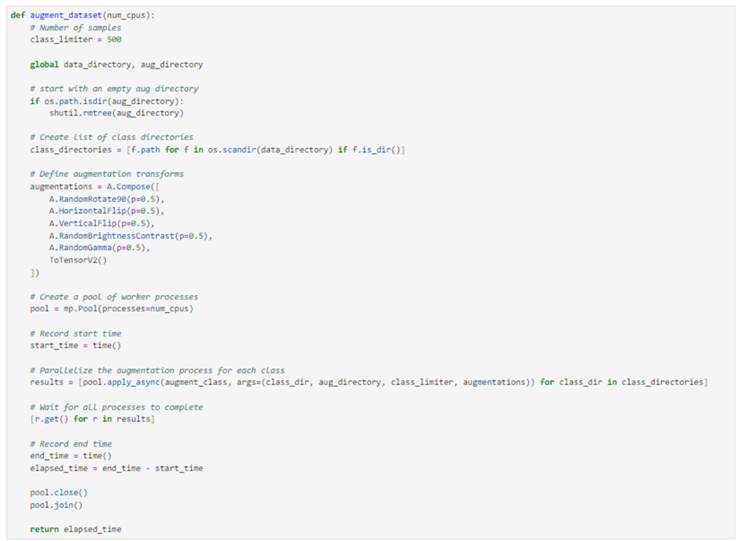

To address the class imbalance in our dataset, the augment_dataset() function serves as a strategic solution by synthetically enhancing the representation of underrepresented classes through data augmentation. This Python function is meticulously designed to automate the augmentation process, utilizing a range of transformations to generate diverse variations of existing images, thereby artificially expanding the dataset. Transformations such as random rotations, horizontal and vertical flips, and adjustments to brightness and contrast are applied, simulating the variability found in real-world conditions. These operations, implemented using the Albumentations library, are applied up to a predefined class_limiter, ensuring that each class reaches a minimum sample threshold, effectively reducing skew in the data distribution.

The augmentation process is further optimized by leveraging multiprocessing, which employs a pool of worker processes to parallelize tasks across multiple CPU cores. This optimization significantly reduces the computational time for the augmentation process, cutting it down from hours to mere minutes. The function initiates by clearing the augmentation directory to provide a clean slate for the new data. Once the augmentation tasks are dispatched, it waits synchronously for all processes to complete, ensuring a well-organized and ready-to-use dataset. Additionally, the function records the elapsed time, providing valuable metrics to evaluate the efficiency of the data augmentation pipeline and identify areas for potential improvement.

This approach not only enriches the dataset but also demonstrates a high level of technical precision and rigor. By introducing diversity to the data and addressing class imbalance, the augment_dataset() function lays a strong foundation for robust and equitable model training, ultimately contributing to the success of the project.

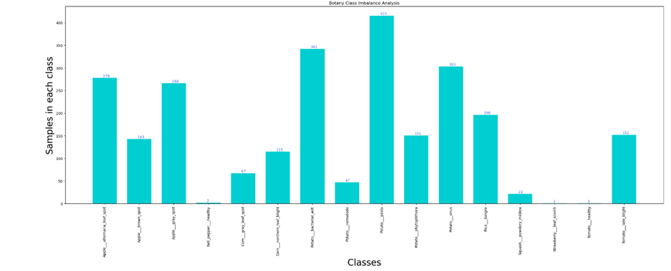

After augmentation, we check the outcome of the augmentation process and present a bar chart showing the number of samples for various plant diseases and healthy plant classes. Data augmentation is a technique used to increase the diversity of data available for training models without collecting new data. This is often achieved by applying a series of transformations to existing data to generate new samples, such as rotating, zooming, or flipping images.

For example, we can see that class such as 'Apple___brown_spot' which originally had 215 samples, 'Corn___healthy' with 21 samples, and 'Potato___nematode' with 68 samples, have been augmented to higher sample sizes. This would suggest that augmentation techniques have been successfully applied to these underrepresented classes to increase their sample sizes, hopefully leading to a more balanced dataset that will allow for better generalization when training machine learning models.

The end goal of such augmentation is to create a more balanced dataset that will not bias the predictive model towards the more represented classes. By doing so, the model's performance across all classes should improve, making it more reliable in practical applications such as automated plant disease detection. It is important to note, however, that while augmentation can help balance a dataset, it must be done carefully to ensure that the synthetic data is realistic and does not introduce artifacts that could mislead the learning algorithm.

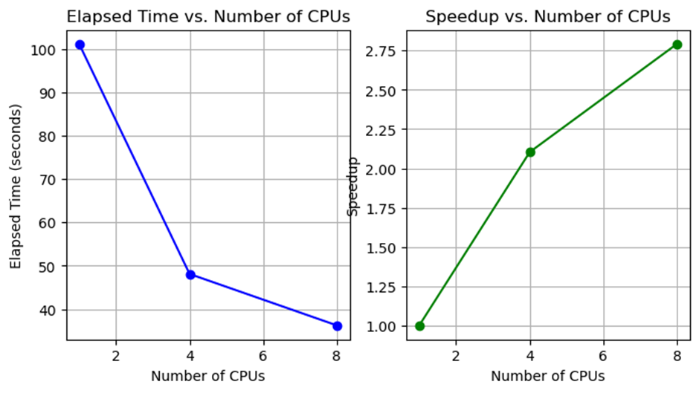

The "Elapsed Time vs. Number of CPUs" graph reveals a significant decrease in elapsed time as the number of CPUs increases from 1 to 4, highlighting the substantial benefits of parallel processing for the data augmentation task. This steep decline indicates good scalability, as the process efficiently leverages multiple CPUs to execute tasks concurrently, substantially reducing the time required to augment the dataset.

As the CPU count increases further, from 4 to 8, there is still a decrease in elapsed time, but the rate of improvement slows. This suggests that overhead costs associated with managing additional processes or the inherent limits of parallel efficiency are beginning to emerge. These factors mean that adding more CPUs yields diminishing returns, as the task approaches the boundaries of its parallelizable potential.

The "Speedup vs. Number of CPUs" graph demonstrates a positive correlation between the number of CPUs and the speedup achieved. Speedup, calculated as the ratio of the time taken with a single CPU to that with multiple CPUs, ideally grows linearly with the number of CPUs under perfect scalability and minimal overhead. However, the observed sub-linear speedup from 4 to 8 CPUs indicates that while performance gains persist, they are less pronounced. This is consistent with real-world scenarios, where factors like inter-process communication and non-parallelizable task components, as described by Amdahl's Law, limit the extent of speedup.

These observations underscore the practical advantages of multiprocessing in data augmentation, significantly reducing preprocessing time — a critical step in developing machine learning models, especially with large datasets. At the same time, they emphasize the need to balance the overhead associated with multiprocessing against its performance benefits, as the gains from adding additional CPUs eventually plateau.

# **Data Modelling:**

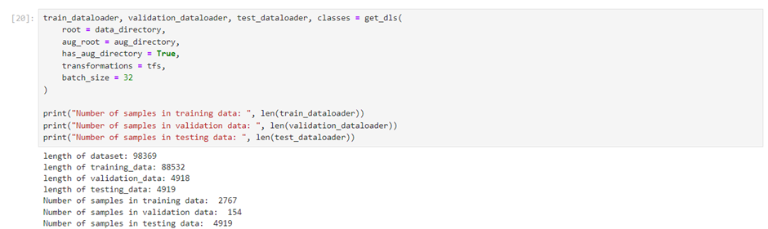

The output provides a clear summary of the dataset's partitioning into training, validation, and testing sets, following the data loading process—a critical step in preparing for model training. The train_dataloader, validation_dataloader, and test_dataloader have been created, each configured with a batch size of 32, enabling efficient data feeding into the neural network during training and evaluation.

The training set contains a significantly larger number of samples, totaling 2767 batches, reflecting a robust and extensive dataset designed to maximize the model’s learning potential. In contrast, the validation set includes 154 batches, while the testing set comprises 4919 batches, aligning more closely with the size of the training set.

This disparity in batch counts among the training, validation, and testing datasets is noteworthy, likely reflecting a strategic focus on providing the model with ample data during training to thoroughly explore the problem space. At the same time, the smaller validation set size indicates a streamlined approach to model tuning and hyperparameter optimization, enabling quicker iteration and evaluation cycles. The substantial size of the testing set ensures a rigorous and comprehensive assessment of the model’s generalization capabilities.

This distribution aligns with standard machine learning practices, where the majority of data is allocated to training, while smaller portions are reserved for validation and testing to optimize and benchmark the model's performance. The reported counts confirm the successful setup of the data processing pipeline, ensuring that the subsequent stages of model training, validation, and evaluation are well-prepared for execution.

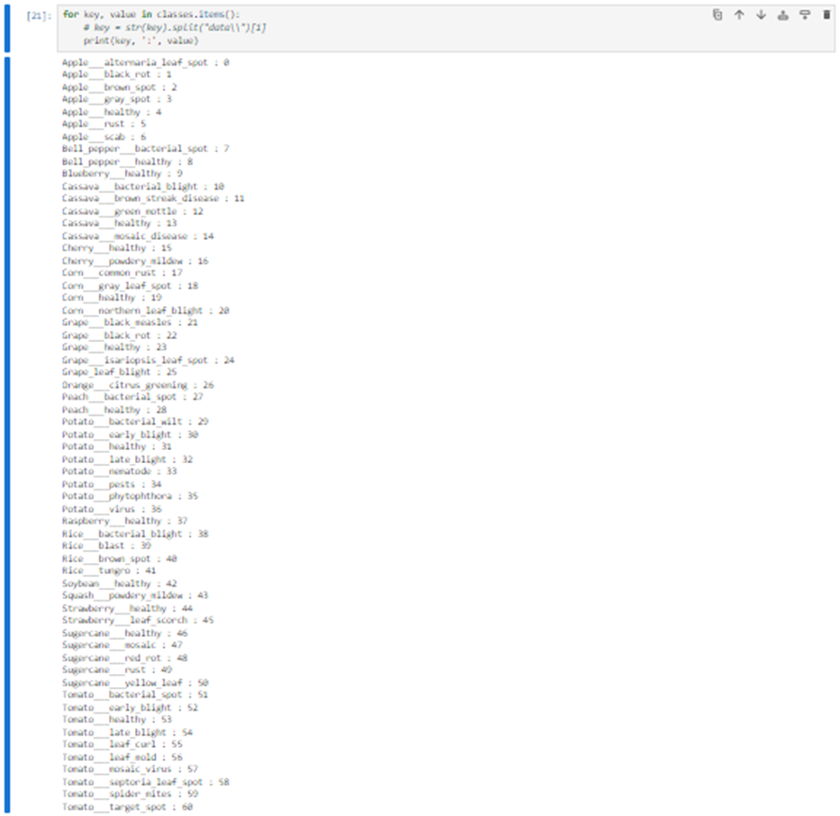

The output provides a key-value mapping, associating each plant infection class with its corresponding number of samples in the dataset. This detailed breakdown is invaluable for understanding the data distribution across different classes, a critical aspect of training and evaluating machine learning models, particularly for classification tasks.

The listed classes encompass a diverse range of plants and their associated diseases or healthy states, such as "Apple___Apple_scab", "Cherry___Powdery_mildew", and "Tomato___Tomato_Yellow_Leaf_Curl_Virus", among others. Analyzing this distribution helps identify underrepresented classes, even after data augmentation, which may still require additional synthetic data generation or other balancing techniques.

Ensuring a balanced dataset is crucial to prevent biases in the predictive model and to maintain consistent performance across all classes, not just those most prevalent in the original data. This level of detail serves as a foundation for implementing effective strategies to optimize model training and evaluation.

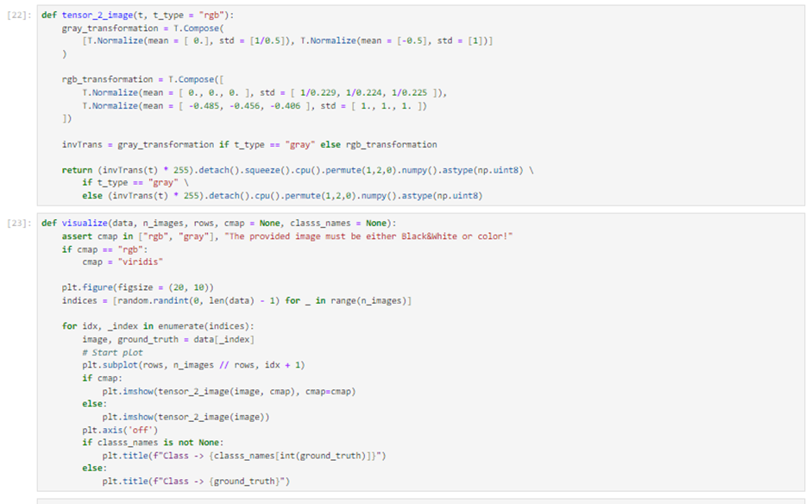

The tensor_2_image() function is a vital component of the machine learning workflow, designed to convert tensors into image formats suitable for visualization or further image processing. It supports both grayscale and RGB images, applying appropriate normalization to ensure tensor data is accurately translated into pixel values. This transformation is essential for preparing data both as input for neural network models, which operate on normalized tensors, and as human-readable visual output.

The visualize function complements this by serving as a critical tool for dataset inspection and model prediction analysis. By randomly selecting images and displaying them in a grid, it enables a qualitative assessment of data post-transformation and provides insights into the model's interpretative capabilities. This functionality is invaluable during the data exploration phase and remains instrumental throughout model tuning. It offers visual feedback that can guide refinements to the model or data preprocessing steps, ensuring that both the data and the model are aligned for optimal performance.

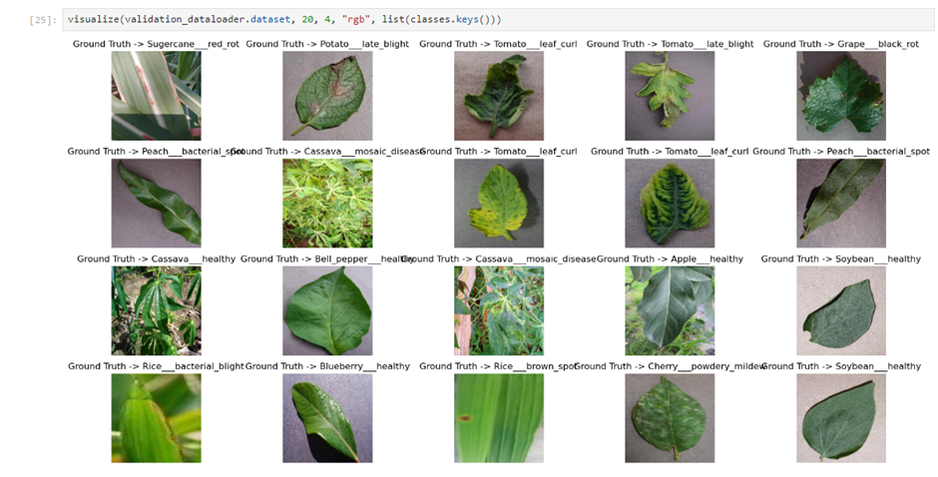

The output image is a collage generated by the visualize function, showcasing various plant leaves in different conditions, ranging from healthy states to a variety of diseases. The visualization features a diverse array of species, including sugarcane, potato, tomato, grape, cassava, peach, bell pepper, rice, blueberry, cherry, and soybean. Each image is labeled with a "Ground Truth" tag, denoting the actual condition or classification of the plant leaf as recorded in the dataset. This type of visual output is a valuable tool for verifying image labels and ensuring the dataset contains accurately annotated examples for training a machine learning model.

This visualization plays a crucial role in manual inspection, allowing researchers to confirm the correctness of dataset annotations and evaluate the diversity of conditions represented. It helps identify mislabeled data, assess the variety of disease manifestations, and ensure that the model is exposed to a broad range of examples. Additionally, these images offer insights into the visual symptoms associated with each plant disease or healthy state, aiding in refining the classification model and deepening domain knowledge about the task.

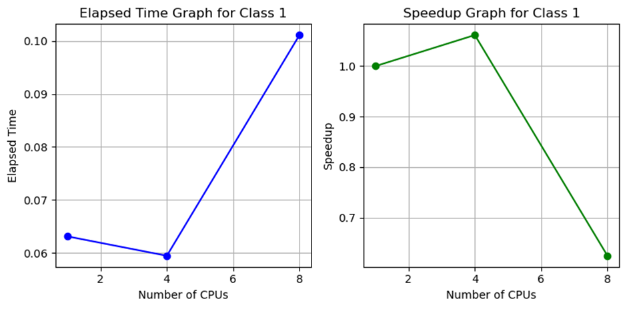

In the "Elapsed Time Graph for Class 1," the data augmentation time decreases as the number of CPUs increases from 2 to 4, as expected with multiprocessing, where tasks are distributed across more processors. However, an unexpected rise in elapsed time occurs when the CPU count increases from 4 to 8. This anomaly could stem from several factors, such as the overhead of managing a larger number of processes, inefficiencies in task distribution and execution, or the inherent limitations of the data augmentation task's parallelizability. It might also result from external system factors, such as temporary system load, or issues in the multiprocessing implementation itself.

In the "Speedup Graph for Class 1," the speedup (compared to using 2 CPUs) increases when the CPU count rises from 2 to 4, reflecting effective parallelization. However, increasing the CPU count to 8 results in a drop in speedup, mirroring the increased elapsed time observed in the elapsed time graph. Ideally, speedup would continue to improve with more CPUs, but the decline indicates diminishing returns. This could be due to overheads, system bottlenecks, or inefficiencies that become more pronounced with additional processors. Notably, the speedup falls below 1 when using 8 CPUs, suggesting that the task performs worse than with fewer CPUs, highlighting scalability challenges or other constraints negatively impacting performance at higher CPU counts.

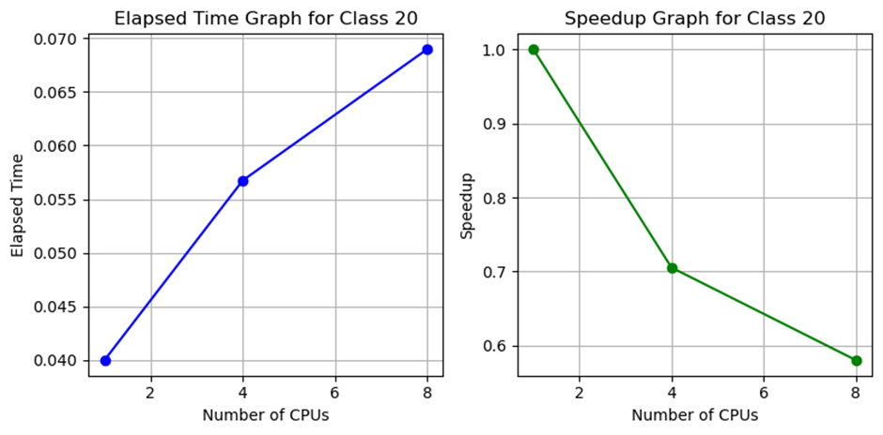

In the "Elapsed Time Graph for Class 20," an unexpected increase in elapsed time is observed as the number of CPUs rises from 2 to 8. Normally, we would anticipate a decrease in elapsed time with more CPUs due to the parallel execution of tasks. This upward trend suggests that parallel processing might be introducing significant overhead, possibly due to inefficiencies in distributing a relatively small workload across too many processors or contention for shared resources. Additionally, the task itself may not be well-suited for parallelization, with the overhead of managing multiple processes outweighing the benefits of concurrent execution.

The "Speedup Graph for Class 20" mirrors this issue, showing a decline in speedup as the number of CPUs increases. Speedup, calculated as the performance ratio between single-CPU and multi-CPU setups, ideally improves with additional CPUs. However, the graph reveals that the process becomes less efficient with more CPUs, and by the time 8 CPUs are used, the speedup falls below 1 (the baseline for 2 CPUs). This indicates that the operation is slower with 8 CPUs than with fewer, highlighting inefficiencies in the parallel processing strategy.

Both graphs underscore a critical issue with the parallelization approach for this class’s data augmentation tasks. These results suggest a need for a closer examination of the parallelization strategy, the nature of the tasks, and the associated overheads. They also serve as a reminder that adding computational resources does not automatically improve performance and that scalability must be evaluated empirically for each specific task.

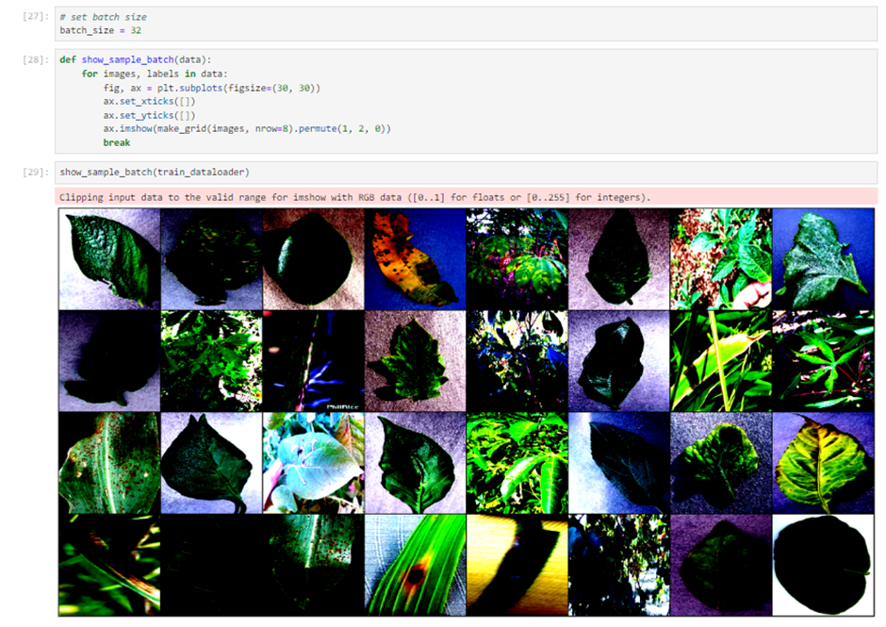

The image showcases a batch of plant leaf samples from a training dataset, arranged in a grid format. This visualization likely serves to inspect a representative portion of the input data used in training a machine learning model. The displayed images exhibit a variety of conditions, including leaves in different stages of health. Some leaves display clear signs of disease or stress, such as discoloration and spotting, while others appear healthy.

A warning message, *"Clipping input data to the valid range for imshow with RGB data ([0..1] for floats or [0..255] for integers)"*, indicates that the image data may not be correctly scaled. If unaddressed, this issue could potentially impact the model's ability to effectively learn from the data. Properly preprocessing and normalizing the images are essential steps to ensure the data is well-suited for training and to avoid such inconsistencies.

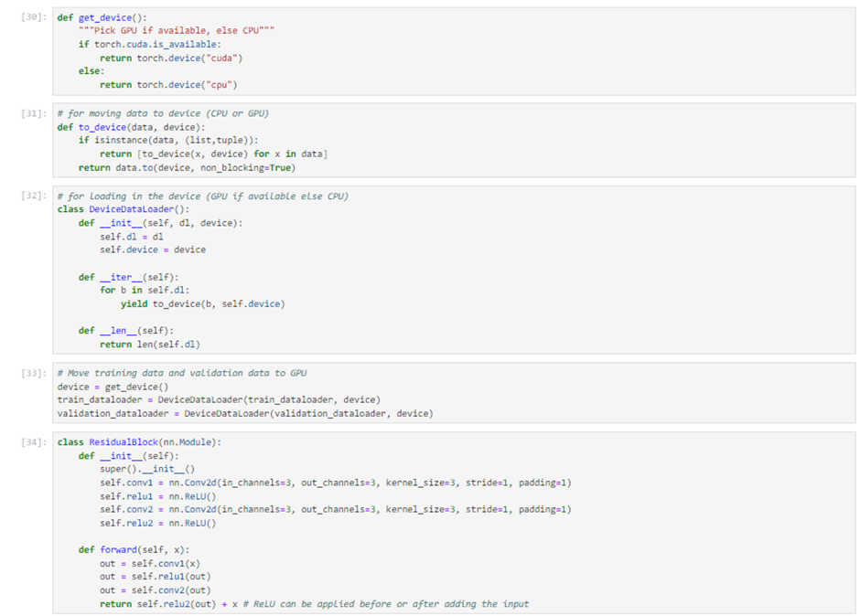

The Python code snippet displayed outlines key steps for preparing and executing a deep learning workflow using the PyTorch library. It includes functions and classes for managing devices, handling data, and defining a neural network architecture.

**Device Management**:  
 The get_device() function is a utility to check for GPU availability (with CUDA support) and return the appropriate device object for PyTorch tensor allocation. This step is essential for leveraging GPU acceleration, which greatly speeds up training. If a GPU is unavailable, it defaults to using the CPU.

**Data Handling**:  
 The to_device() function and the DeviceDataLoader class work together to ensure data is automatically moved to the correct device (GPU or CPU) before being processed by the model. to_device() transfers data batches to the specified device, optimizing performance with non-blocking operations. The DeviceDataLoader class wraps around a standard PyTorch DataLoader, automating this transfer for each batch during the training loop. This abstraction simplifies the process and enables device-agnostic code, improving usability and readability.

**Residual Block Definition**:  
 The ResidualBlock class implements a basic building block for ResNet architectures, renowned for their efficiency in training deep neural networks. Inheriting from nn.Module, the class defines a residual block comprising convolutional layers with a kernel size of 3, stride of 1, and padding to preserve spatial dimensions. It includes ReLU activation functions and a forward method that passes data through the convolutional layers, applies activations, and incorporates the original input via a residual connection. This design helps mitigate the vanishing gradient problem, enabling effective training of deep networks.

**Overall Structure**:  
 These components together form a robust framework for setting up and training a deep neural network in PyTorch. The device management utilities optimize resource utilization, the data handling functions ensure seamless device transitions, and the modular ResidualBlock design supports constructing scalable and reusable models. The code reflects best practices in machine learning and software development, emphasizing efficiency, modularity, and reusability, making it well-suited for complex tasks like image classification.

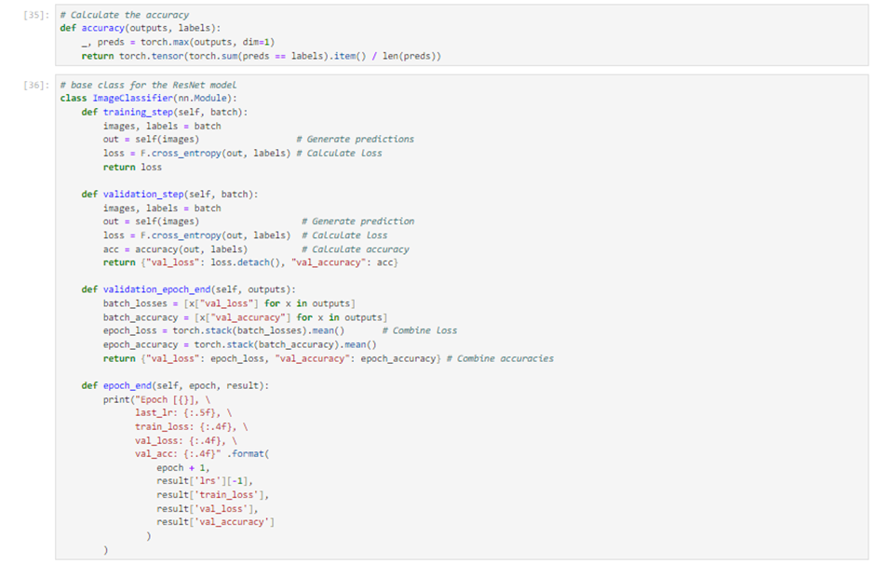

The code provides a structured framework for training and validating a neural network model using PyTorch. At its core is an accuracy function that calculates how often the model's predictions align with the true labels. This function is vital for monitoring the model's learning progress and performance. It follows a standard PyTorch workflow, where the model's raw outputs are passed through a softmax function to identify the most probable class labels. These predictions are then compared against the actual labels, resulting in a Boolean tensor that indicates correct predictions. The mean of this tensor gives the overall accuracy metric.

The ImageClassifier class, an extension of PyTorch's nn.Module, encapsulates the model's behavior. Its training_step method processes batches of data, performs a forward pass through the model to generate predictions, and calculates the loss using cross-entropy—a widely used loss function for classification tasks. Meanwhile, the validation_step method not only computes the loss for each batch during evaluation but also calculates accuracy, providing critical insights into the model's performance on unseen data. The validation_epoch_end method aggregates the batch-wise validation results, offering a comprehensive overview of the model's loss and accuracy across the entire validation dataset. These metrics are crucial for assessing the model's ability to generalize beyond the training data.

To conclude each epoch, the epoch_end method outputs the key metrics, giving visibility into the model's progress after completing one cycle of training and validation. This feedback is invaluable for tracking improvements over time and diagnosing issues such as overfitting or underfitting. The code's organized and modular design supports an efficient training and evaluation workflow, enabling rigorous and iterative development of robust neural network models.

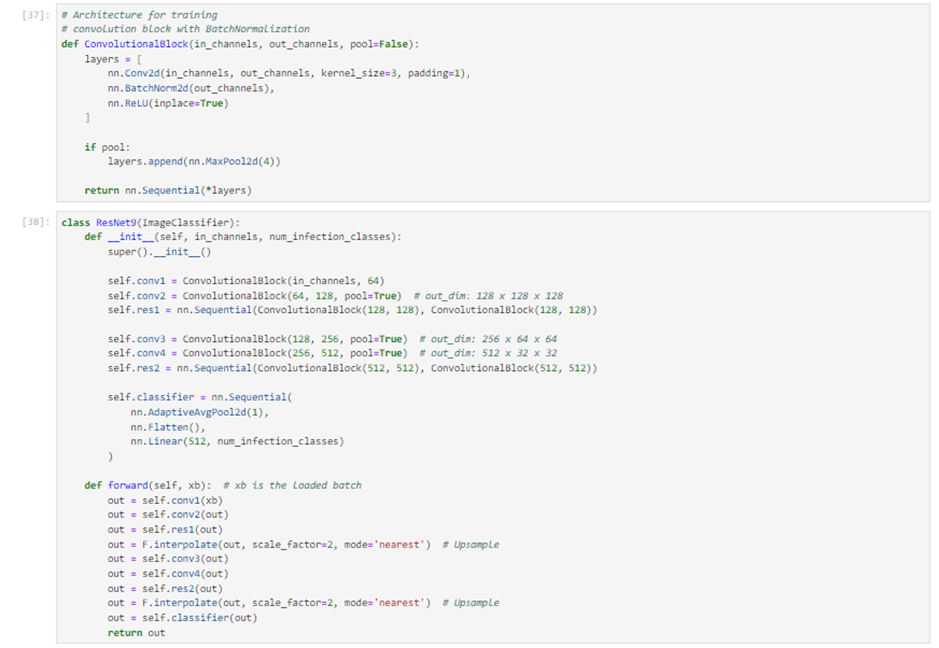

The code snippet defines the architecture of a deep learning model, likely designed for image classification tasks, following the principles of a Residual Network (ResNet). It begins with a ConvolutionalBlock function, which constructs a sequential neural network module. This module includes a convolutional layer, batch normalization, and a ReLU activation function. An optional pooling layer is included if the pool parameter is set to True.

The ResNet9 class, which inherits from the ImageClassifier base class, implements a streamlined version of the ResNet architecture. ResNets are known for their use of residual blocks with skip connections, which help train deeper networks by addressing the vanishing gradient problem. In this implementation, multiple convolutional blocks are stacked, progressively increasing the number of channels while reducing the spatial dimensions of the input. The architecture begins with a convolutional layer expanding the input to 64 channels, followed by layers that double the channels and downsample spatial dimensions, culminating in 512 channels.

The model is divided into distinct sections: convolutional blocks, optional pooling layers, and a classifier section. The classifier comprises an adaptive pooling layer, a flattening operation, and a fully connected layer. The adaptive pooling layer ensures the output has a fixed size, regardless of input dimensions, enabling flexibility for varying input resolutions. The flattening operation converts two-dimensional feature maps into a one-dimensional tensor, suitable for the fully connected layer, which performs the final classification.

In the forward method, the input batch (xb) is passed sequentially through the network's layers. The architecture includes upsampling steps before specific blocks, likely to preserve spatial resolution for further processing.

This ResNet9 implementation is designed to accommodate a variable number of input channels and output classes, making it highly versatile for different image classification tasks. It exemplifies modern neural network design, emphasizing both performance and computational efficiency.

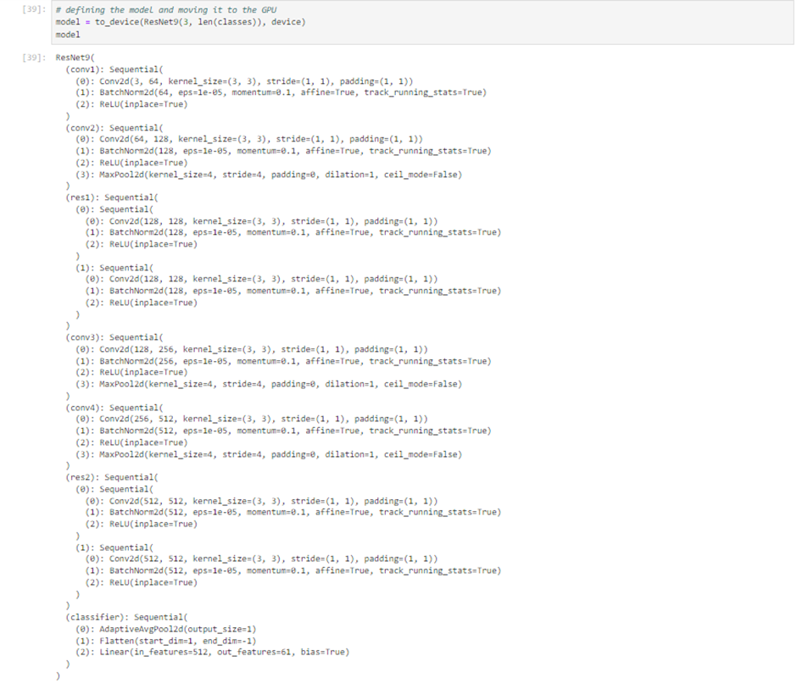

The model is instantiated from the ResNet9 class and transferred to the GPU using the to_device() function, which typically wraps PyTorch's .to() method. This step is standard in deep learning workflows, as GPUs significantly accelerate the parallel computations required for training neural networks compared to CPUs.

The ResNet9 class, detailed in the code snippet, inherits from PyTorch's nn.Module and defines a sequence of convolutional layers, batch normalization steps, and ReLU activations, forming the convolutional blocks characteristic of the ResNet architecture. The architecture includes multiple convolutional layers (conv1, conv2, conv3), each followed by batch normalization and ReLU activations. Some of these layers are paired with a max pooling layer (MaxPool2d) to downsample the spatial dimensions of the feature maps. This downsampling reduces computational overhead and increases the receptive field of subsequent layers, enabling the model to capture more contextual information.

The ResNet architecture also incorporates skip connections, which are not explicitly detailed in the snippet but are integral to the convolutional blocks (ConvolutionalBlock). These connections allow gradients to bypass one or more layers during backpropagation, mitigating the vanishing gradient problem and facilitating the training of deep networks.

The model concludes with a classifier block comprising an adaptive average pooling layer, which produces a fixed-size output tensor regardless of input dimensions, a flattening operation to convert 2D feature maps into a 1D tensor, and a linear layer that maps these features to the number of output classes.

This structured design ensures computational efficiency, scalability, and effective gradient flow, making the ResNet9 model well-suited for complex image classification tasks.

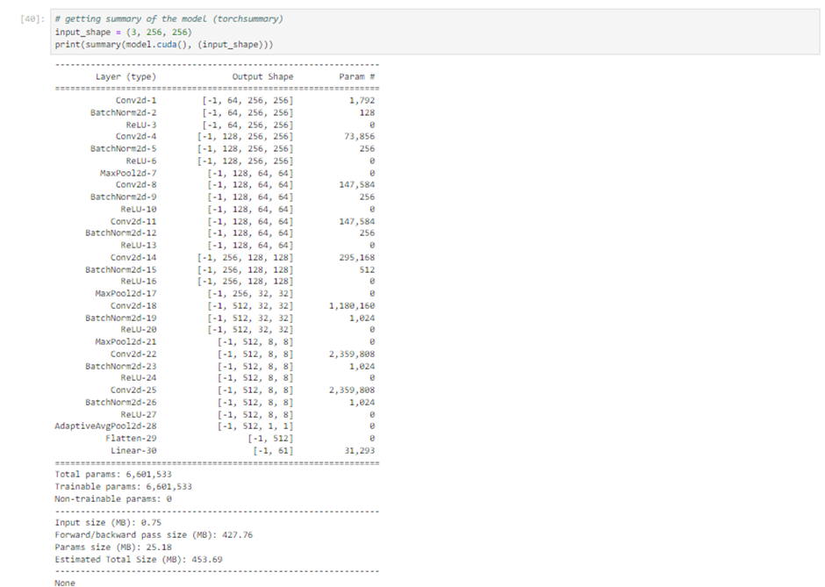

The torchsummary utility in PyTorch provides a comprehensive summary of a neural network model. This summary includes detailed information about each layer, such as the layer type (e.g., convolutional, batch normalization, ReLU activation, max pooling, adaptive average pooling, linear), the output shape of the data as it flows through each layer, and the number of parameters associated with each layer.

This utility is invaluable for understanding the architecture and complexity of the model. It highlights the multi-layer structure of a convolutional neural network, showing how input data is transformed at each stage. The output shape reveals the changes in spatial dimensions of the feature maps, while the number of parameters indicates the capacity and computational requirements of the model. For example, layers like Conv2d and MaxPool2d alter the spatial dimensions, whereas layers such as BatchNorm2d and ReLU stabilize and accelerate training without affecting data size. The AdaptiveAvgPool2d layer ensures a consistent output size, making the model flexible for inputs of varying dimensions. The final Linear layer maps the extracted features to the target classes for prediction.

The summary also distinguishes between trainable and non-trainable parameters. Trainable parameters are updated during training via backpropagation, while non-trainable parameters, such as those in certain normalization layers or frozen pre-trained layers, remain constant. This distinction is critical for understanding the dynamics of the model during training and fine-tuning.

Additionally, the utility provides insights into the computational demands of the model, including memory usage for a single forward pass with the specified input size. This includes memory required for storing model parameters and intermediate data during forward and backward passes. Such information is essential for evaluating whether the model is compatible with specific hardware configurations, especially in resource-constrained environments like edge devices, or for deployment scenarios with limited computational and memory resources.

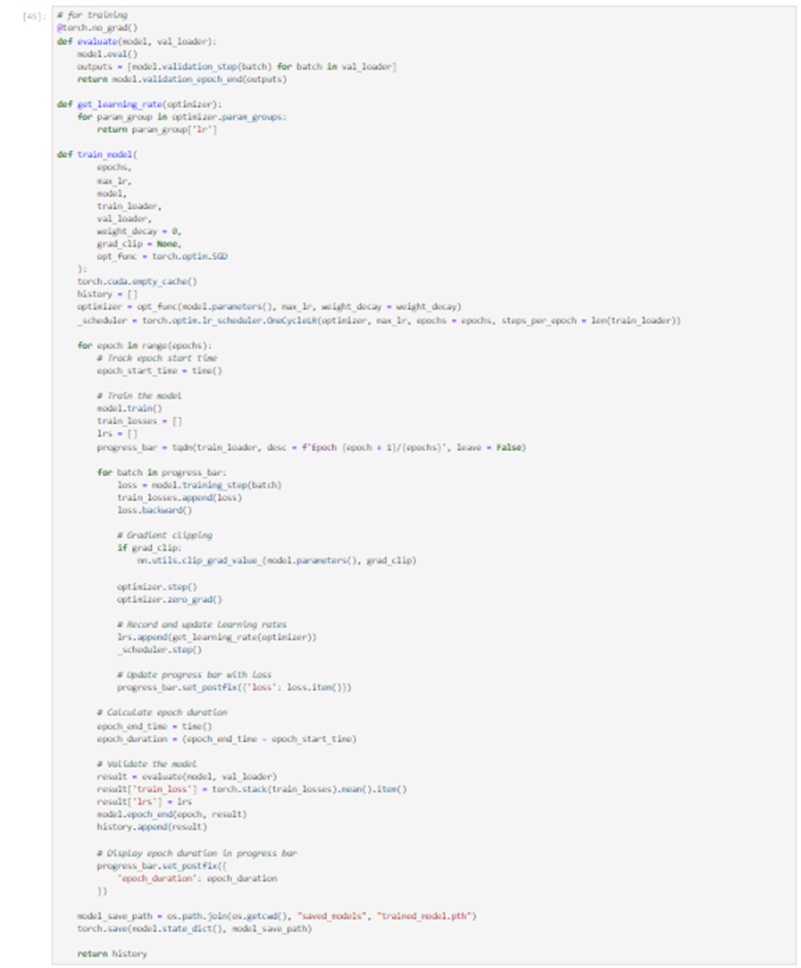

The Python code outlines a detailed training procedure for a deep learning model using PyTorch, incorporating modern best practices such as gradient clipping, learning rate scheduling, and progress visualization.

The fit function serves as the core of the training loop, accepting parameters such as the number of epochs, model, optimizer, loss function (criterion), data loaders for training and validation sets, device (CPU or GPU), maximum learning rate, weight decay for regularization, and a gradient clipping threshold. The inclusion of an optimizer and a learning rate scheduler—specifically the OneCycleLR scheduler—indicates a well-structured optimization process. The one-cycle policy dynamically adjusts the learning rate, starting low, peaking midway, and tapering off toward the end of the cycle, often leading to faster convergence.

During training, the model is iteratively trained and validated over the specified number of epochs. For each epoch, the code records the duration, processes batches of training data, calculates loss, performs backpropagation (.backward()), and updates the model parameters (optimizer.step()). Gradient clipping is applied by capping the gradient norm to a specified threshold (grad_clip), preventing exploding gradients that can destabilize training. After each batch, the learning rate scheduler adjusts the learning rate for subsequent updates. Once all batches are processed, the model is evaluated on the validation set, calculating metrics like average loss and accuracy.

At the end of each epoch, the code logs and displays relevant metrics, including training duration, validation loss, and accuracy, often using a progress bar for clear and user-friendly monitoring. Once training is complete, the model's state is saved to a file, enabling future inference or additional training.

This training loop represents a robust and efficient approach to deep learning model development. It incorporates techniques such as learning rate scheduling for faster convergence, gradient clipping for stability, and detailed progress reporting to enhance the training process and ensure strong model performance.

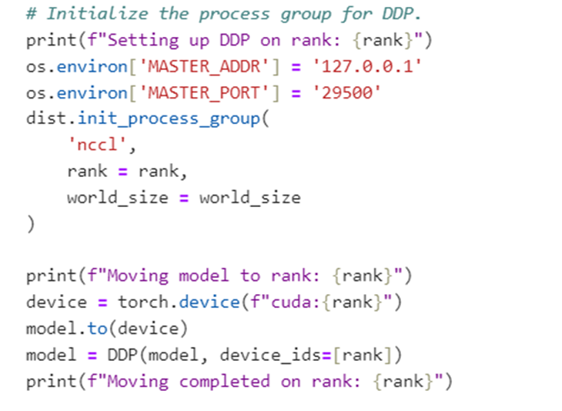

To enhance our data processing and model training capabilities, we have integrated a Distributed Data Parallel (DDP) setup into our workflow. This approach leverages multiple GPUs to distribute and parallelize the workload, significantly improving the efficiency and speed of training large-scale machine learning models.

The setup begins by configuring the necessary environment for DDP. We define a MASTER_ADDR and a MASTER_PORT to enable all processes within the distributed system to communicate with the master node. This master node orchestrates the processes and facilitates seamless communication among them. Using PyTorch’s init_process_group function, we initialize a process group with nccl as the backend. NCCL, the NVIDIA Collective Communications Library, is specifically optimized for multi-GPU and multi-node training, making it ideal for our requirements.

After initializing the process group, we assign each process a specific part of the dataset and allocate the model to the appropriate device. A confirmation message, such as "Moving model to rank," signals the allocation of the model to a specific GPU corresponding to the process rank. The use of torch.device(f"cuda:{rank}") ensures that each process places its model replica on the correct GPU, a crucial step for efficient distributed training.

Next, the model is wrapped with the DDP class, a critical step that synchronizes training across multiple GPUs. The DDP wrapper ensures that gradients calculated on each GPU are averaged and synchronized across all replicas, maintaining uniform updates during training. Specifying device_ids=[rank] ensures that each DDP-wrapped model is associated with the appropriate GPU. Once the model is successfully moved and wrapped, a confirmation statement indicates the completion of this process for the respective rank.

This DDP setup maximizes the combined computational power of multiple GPUs, enabling us to handle larger datasets and more intensive training tasks than would be possible with a single GPU. By utilizing DDP, we not only accelerate the training process but also enhance the robustness and scalability of our model training efforts, making it a powerful addition to our workflow.

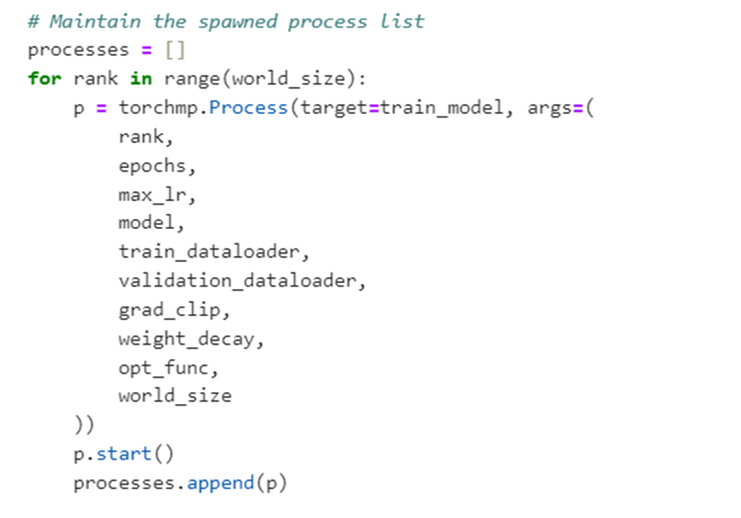

We have harnessed PyTorch's multiprocessing capabilities to significantly enhance the efficiency of our model training process, particularly by leveraging the computational power of multiple GPUs.

The training routine begins by initializing a list to keep track of the processes we spawn. For each available GPU in our world_size, a new process is created, each assigned a unique rank. These processes independently execute the train_model function, which is passed the necessary parameters, including hyperparameters and the shared model. While each process begins with its own replica of the model, the Distributed Data Parallel (DDP) setup ensures that all replicas remain synchronized, even as they train independently.

As each process is started, it is added to our process list, allowing us to maintain references to all running processes. At the end of the training routine, we enforce synchronization by calling join() on each process, ensuring all training tasks are completed before proceeding. This critical step coordinates the parallel efforts across GPUs, consolidating the results of distributed training.

Once all processes have finished, the total training duration is calculated by comparing the end time with the start time. Thanks to concurrent processing, this duration is expected to be significantly shorter than that of a single-process training run. This approach maximizes hardware utilization, enabling us to tackle larger datasets and train more complex models with improved efficiency and agility.

By integrating this multiprocessing architecture into our training pipeline, we have laid a foundation for scalable and efficient deep learning workflows. This strategy not only reflects our commitment to optimizing performance but also positions us to meet the increasing demands of deep learning research and application development with confidence and precision.

The snippet begins by evaluating the model on the validation dataset before training, providing a baseline for validation loss and accuracy. This baseline is crucial for comparing the model's improvement throughout the training process.

Key hyperparameters for training are then defined, including the number of epochs, learning rate, gradient clipping value, and weight decay. The learning rate is a critical factor in controlling how quickly the model updates its weights; setting it too high risks convergence to a suboptimal solution, while too low a value may slow down the training process or cause the model to get stuck. Gradient clipping is implemented to stabilize training by capping excessively large gradients, and weight decay serves as a regularization technique to mitigate overfitting by penalizing large weights.

The training process is initiated with the recording of the start time. The fit function handles the training loop, encompassing forward and backward passes, weight updates via the optimizer, and adjustments to the learning rate based on the scheduler. This setup ensures that the model is optimized effectively while adhering to the defined hyperparameters.

After training is completed, the end time is recorded, and the total duration of the training session is calculated. A detailed log of metrics is displayed for each epoch, including the last learning rate, training loss, validation loss, and validation accuracy. These metrics offer critical insights into the model's performance and learning trajectory.

The training loss typically decreases with each epoch, reflecting the model's ability to better fit the training data. Validation metrics, on the other hand, provide a measure of how well the model generalizes to unseen data. A rise in validation loss or a decline in validation accuracy could signal overfitting, where the model becomes overly tailored to the training data, including noise and outliers, at the expense of generalization.

Overall, this output provides a thorough overview of the training process, facilitating the monitoring of the model's progress and the evaluation of hyperparameter effectiveness. It is an essential step in developing and refining machine learning models, enabling fine-tuning and optimization based on empirical results.

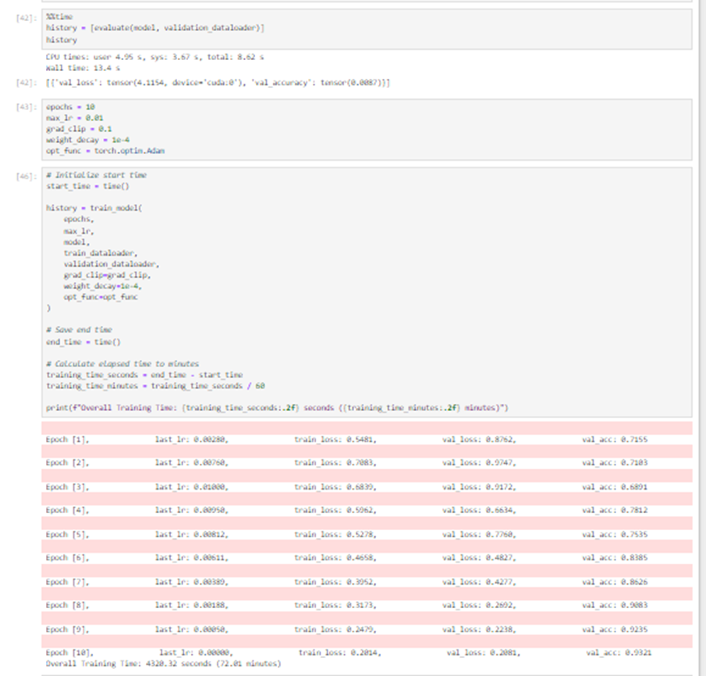

The snippet begins by evaluating the model's validation loss and accuracy before training, establishing a baseline for its performance on the validation dataset. This baseline serves as a reference point for assessing improvements during the training process.

Key hyperparameters for training are defined, including the number of epochs, learning rate, gradient clipping value, and weight decay (a regularization method). The learning rate is a critical factor in determining the speed and quality of the learning process. If set too high, the model might converge prematurely to a suboptimal solution; if too low, it could result in prolonged training or stagnation in a local minimum. Gradient clipping is employed to cap excessively large gradients, stabilizing the training process, while weight decay penalizes large weights to reduce the risk of overfitting.

The training process starts with the recording of the start time. Using the fit function, the model undergoes forward and backward passes, weight updates via the optimizer, and learning rate adjustments based on a scheduler. This process ensures efficient optimization while adhering to the defined hyperparameters.

Once training concludes, the end time is recorded, and the total training duration is calculated. The results are presented in a tabulated format, detailing metrics for each epoch, including the last learning rate, training loss, validation loss, and validation accuracy. These metrics provide valuable insights into the model's learning trajectory and performance.

Training loss is expected to decrease progressively, reflecting the model's improving ability to fit the training data. Validation metrics, on the other hand, indicate the model's capacity to generalize to unseen data. Any rise in validation loss or decline in validation accuracy could signal overfitting, where the model becomes too tailored to the training data, including its noise and outliers, at the expense of generalization.

In summary, this output offers a detailed view of the training process, enabling effective monitoring of the model's progress and the evaluation of hyperparameter choices. It is a vital step in model development, supporting fine-tuning and optimization based on empirical results.

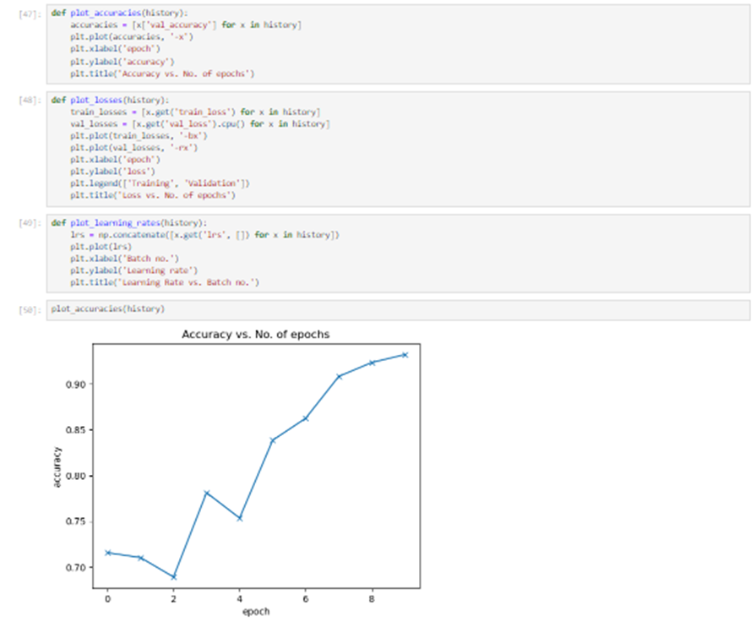

The plot_accuracies function takes a history object (likely a list or dictionary of metrics collected during training) and generates a plot of validation accuracy over time. This plot provides valuable insights into the model's performance on the validation set, showing how its ability to classify validation data improves with each epoch (a full iteration over the dataset). The graph typically displays a steady increase in accuracy, indicating that the model is effectively learning and improving over time.

The second function, plot_losses, likely creates a plot comparing training and validation losses across epochs. Monitoring both losses is critical for identifying potential issues, such as overfitting, where the model achieves low training loss but high validation loss, indicating poor generalization to unseen data. While not explicitly shown in the image, losses are expected to decrease over time, with training and validation losses remaining close to each other as the model learns.

The plot_lrs function visualizes changes in the learning rate over time, providing insights into the effects of learning rate scheduling. Learning rate schedules adjust the learning rate dynamically during training to optimize the convergence process. A well-tuned learning rate schedule can significantly improve training efficiency and final model performance, making this visualization a valuable tool.

The final graph, showing a clear upward trend in accuracy over epochs, demonstrates that the model is benefiting from each additional training epoch. This type of visualization is a simple yet powerful way to monitor training progress, enabling machine learning practitioners to quickly assess model performance and make informed adjustments as needed.

The plot_accuracies function generates a plot of validation accuracy over time using a history object, likely a list or dictionary containing metrics collected during training. This plot provides valuable insights into how the model's performance on the validation set evolves with each epoch (a complete pass through the dataset). A steady increase in accuracy, as often shown in the graph, indicates that the model is learning effectively and improving its ability to classify validation data.

The plot_losses function likely creates a plot comparing training and validation losses over the epochs. Tracking both losses is essential for diagnosing issues such as overfitting, where the model achieves low training loss but exhibits high validation loss, indicating poor generalization to new data. Although not explicitly shown, losses are expected to decrease over time, with training and validation losses ideally remaining close to one another as the model learns.

The plot_lrs function visualizes changes in the learning rate during training, offering insights into the impact of learning rate scheduling. Learning rate schedules dynamically adjust the learning rate to optimize the convergence process. A well-designed learning rate schedule can significantly enhance training efficiency and improve final model performance, making this visualization a valuable tool for fine-tuning the training process.

The final graph, displaying a clear upward trend in validation accuracy over epochs, reflects that the model is benefiting from the training process and becoming increasingly effective. These visualizations collectively provide a straightforward yet powerful way to monitor the training progress, enabling practitioners to assess model performance at a glance and make informed adjustments to improve outcomes.

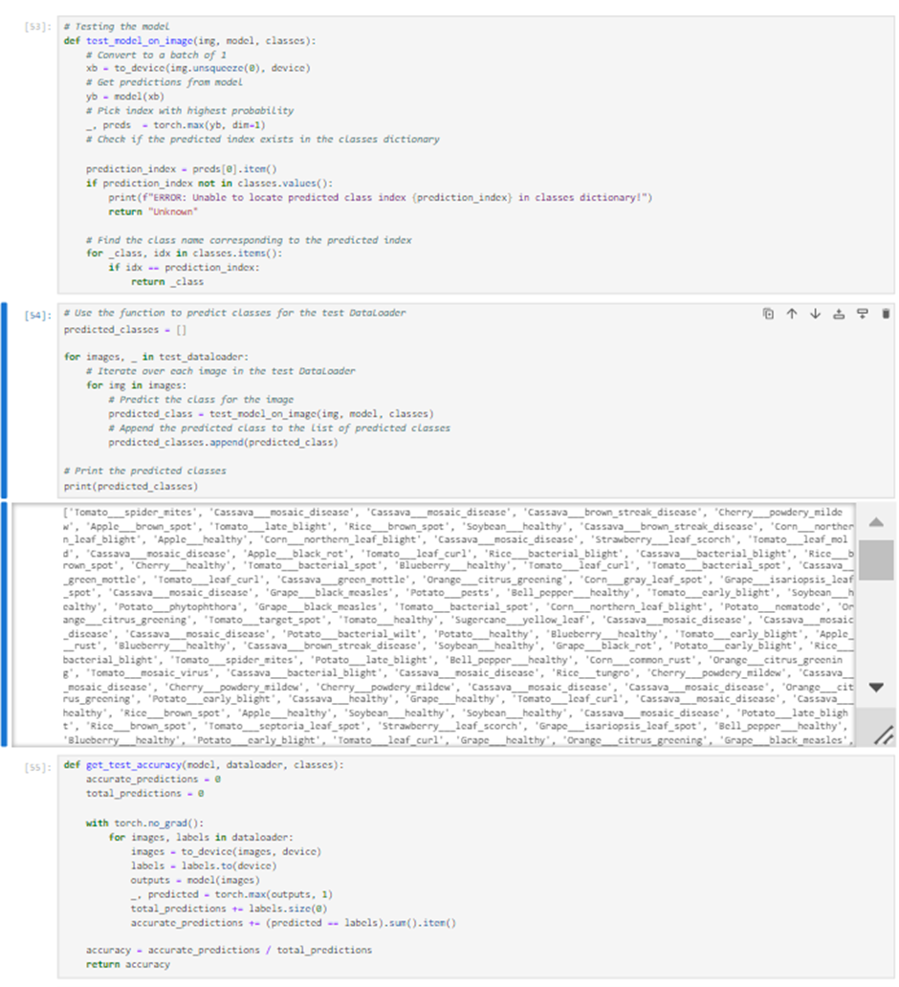

The test_model_on_image function takes an image and a trained model as inputs. It preprocesses the image to meet the model's input requirements, such as resizing and normalization, and converts it into a batch of size 1, as PyTorch models expect batched inputs. The model then predicts the class probabilities for this single image. The class with the highest probability is identified as the predicted class, and its corresponding name is retrieved using a predefined class dictionary. The function includes error handling to address cases where the predicted class index is not found in the dictionary. The predicted class name is returned as the output.

The function is subsequently applied to each image in a test dataset using a loop. For each test image, the predicted class is appended to the predicted_classes list, which is printed to display the predicted class for each image.

The get_test_accuracy function calculates the overall accuracy of the model on the test dataset. It iterates through the dataset, making predictions and comparing them to the true labels. Accuracy is computed as the ratio of correct predictions to the total number of predictions, providing a quantitative measure of the model's performance.

This code represents the inference phase of a machine learning workflow, where a trained model is used to make predictions on unseen data. The overall accuracy serves as a key metric for assessing the model's generalization ability and practical effectiveness, validating its performance beyond the training data. This process is essential for evaluating how well the model can perform in real-world scenarios.

